**Step 1: Install the Sample Application**

1. Open index.html in your browser and click the **Calculate** button.

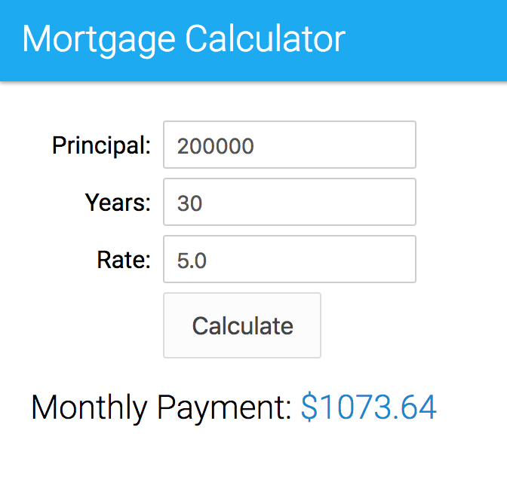

**Step 2: Set Up Babel**

As you just saw, the current version of the application runs in current browsers without compilation: it is written in pure ECMAScript 5. In this section, we set up Babel so that we can start using ECMAScript 6 features in the next unit.

1. Open a command prompt, and navigate (cd) to the es6-fundamentals-student directory.
2. Type the following command to create a package.json file:
3. npm init

Press the **Return** key in response to all the questions to accept the default values.

1. Type the following command to install the **babel-cli** and **babel-core** modules:
2. npm install babel-cli babel-core --save-dev

There are different ways to install and run Babel. For example, you could also install Babel globally and run it from the command line. Refer to the [**Babel**](http://babeljs.io/docs/setup/) documentation for more information.

1. Type the following command to install the **ECMAScript 2015 preset**:

npm install babel-preset-es2015 --save-dev

1. In Babel 6, every transformer is a plugin that can be installed separately. A preset is a group of related plugins. Using a preset, you don’t have to install and update dozens of plugins individually.
2. Install [http-server](https://github.com/indexzero/http-server) in your project. **http-server** is a lightweight web server we use to run the application locally during development.

npm install http-server --save-dev

1. Open package.json in your favorite code editor. In the scripts section, remove the **test** script, and add two new scripts: a script named **babel** that compiles main.js to a version of ECMAScript that can run in current browsers, and a script named **start** that starts the local web server. The scripts section should now look like this:

"scripts": {

"babel": "babel --presets es2015 js/main.js -o build/main.bundle.js",

"start": "http-server"

},

1. In the es6-fundamentals-student directory, create a build directory to host the compiled version of the application.

**Step 3: Build and Run**

1. On the command line, make sure you are in the es6-fundamentals-student directory, and type the following command to run the **babel** script and compile main.js:

npm run babel

1. Open **index.html** in your code editor, and modify the <script> tag as follows to load build/main.bundle.js, the compiled version of js/main.js:

<script src="build/main.bundle.js"></script>

1. Open a new command prompt. Navigate (cd) to the es6-fundamentals-student directory, and type the following command to start http-server:

npm start

If port 8080 is already in use on your computer, modify the **start** script in package.json and specify a port that is available on your computer. For example:

"scripts": {

"babel": "babel --presets es2015 js/main.js -o build/main.bundle.js",

"start": "http-server -p 9000"

},

1. Open a browser and access [http://localhost:8080](http://localhost:8080/)
2. Click the **Calculate** button to calculate the monthly payment for the mortgage.



1. Open build/main.bundle.js in your code editor and notice that the generated code is virtually identical to the source code (js/main.js). This is because the current code in main.js doesn’t include any ECMAScript 6 feature.